DISCRETE STRUCTURES - SAMPLE EXAM

**NEU 2022-2023 Spring Semester**

goodluck

* Time: 1 hour
* Number of questions: 20-mcqs
* Marks: out of 100
* Topics covered: Logic, Proof, Sets
* Difficulty: Intermediate-Difficult

Question 1: _________ is a statement that is either true or false. ( Easy )

* Proposition
* Logic
* Manipulation
* Question

Question 2: It is raining today. ( EASY )

* Proposition
* Logic
* Manipulation
* Question

Question 3: More complex propositional statements can be build from elementary statements using _________. ( Easy )

* Logic
* Logical Connectives
* Proposition
* Negation

Question 4: When p is True, then ¬ p will be: ( Medium )

* True
* False

Question 5: Which of the following Statements is True: ( Medium )

* p ∧ q is Conjunction and p ∨ q is Disjunction
* p ∧ q is Disjunction and p ∨ q is Conjunction
* p ∧ q is Equal to ( And ) and p ∨ q is equal to ( Or )
* A and C

Question 6: p ⊕ q will be True when: ( Difficult )

* p is False, ¬ q is True
* p is False, ¬ q is False
* ¬ p is False, q is True
* B and C

Look at the following Truth Table, and use it to solve Question 7 and 8

|  |  |  |
| --- | --- | --- |
| p | q | p 🡪 q |
| T | T | T |
| T | F | _____ |
| F | T | T |
| F | F | T |

Question 7: Fill the blank in the Truth Table: ( Easy )

* True
* False

Question 8: What is p called in that implication Truth Table: ( Medium )

* Conclusion
* Hypothesis
* Truth

Question 9: “If it rains, then today is Wednesday” Which of the following is the Contrapositive for the sentence: ( Difficult )

Hint: ¬q → ¬p

* If today is Wednesday, then it’s going to rain
* If it’s not Wednesday, then it’s not going to rain today
* If it does not rain, then today is not Wednesday

Question 10: Which among these is a Tautology: ( Difficult )

* (p ∧ q) → p <=> F
* (p ∧ q) → p <=> T
* (p ∨ q) → p <=> T
* (p ∨ q) → p <=> F

Question 11: According to the Direct Proof Strategy, if n is odd then we will assume that the conclusion (n^2) is ______. ( Easy )

* Odd
* Even
* Contradiction
* Proved

Question 12: According to the Indirect Proof Strategy, if n is odd then we will assume that the premises (n) and conclusion (3n+2) are ______. ( Medium )

* Odd
* Even
* Contradiction
* Proved

Question 13: According to the Contradiction Strategy, if (3n+2) is odd and n is odd then we will assume that (n) is ______. ( Difficult )

* Odd
* Even
* Contradiction
* Proved

Question 14: A set is an ________ collection of objects ( Easy )

* Ordered
* Unordered
* Element
* Members

Question 15: what is Z+ ( Easy )

* Integers
* Positive Integers
* Rational Numbers
* Real Numbers

Question 16: What is |P({ })|equal to ( Medium )

* 0
* Undefined
* Infinity
* 1

Question 17: Use the following Picture to answer the question: ( Difficult )

Which one Illustrates the complement of A

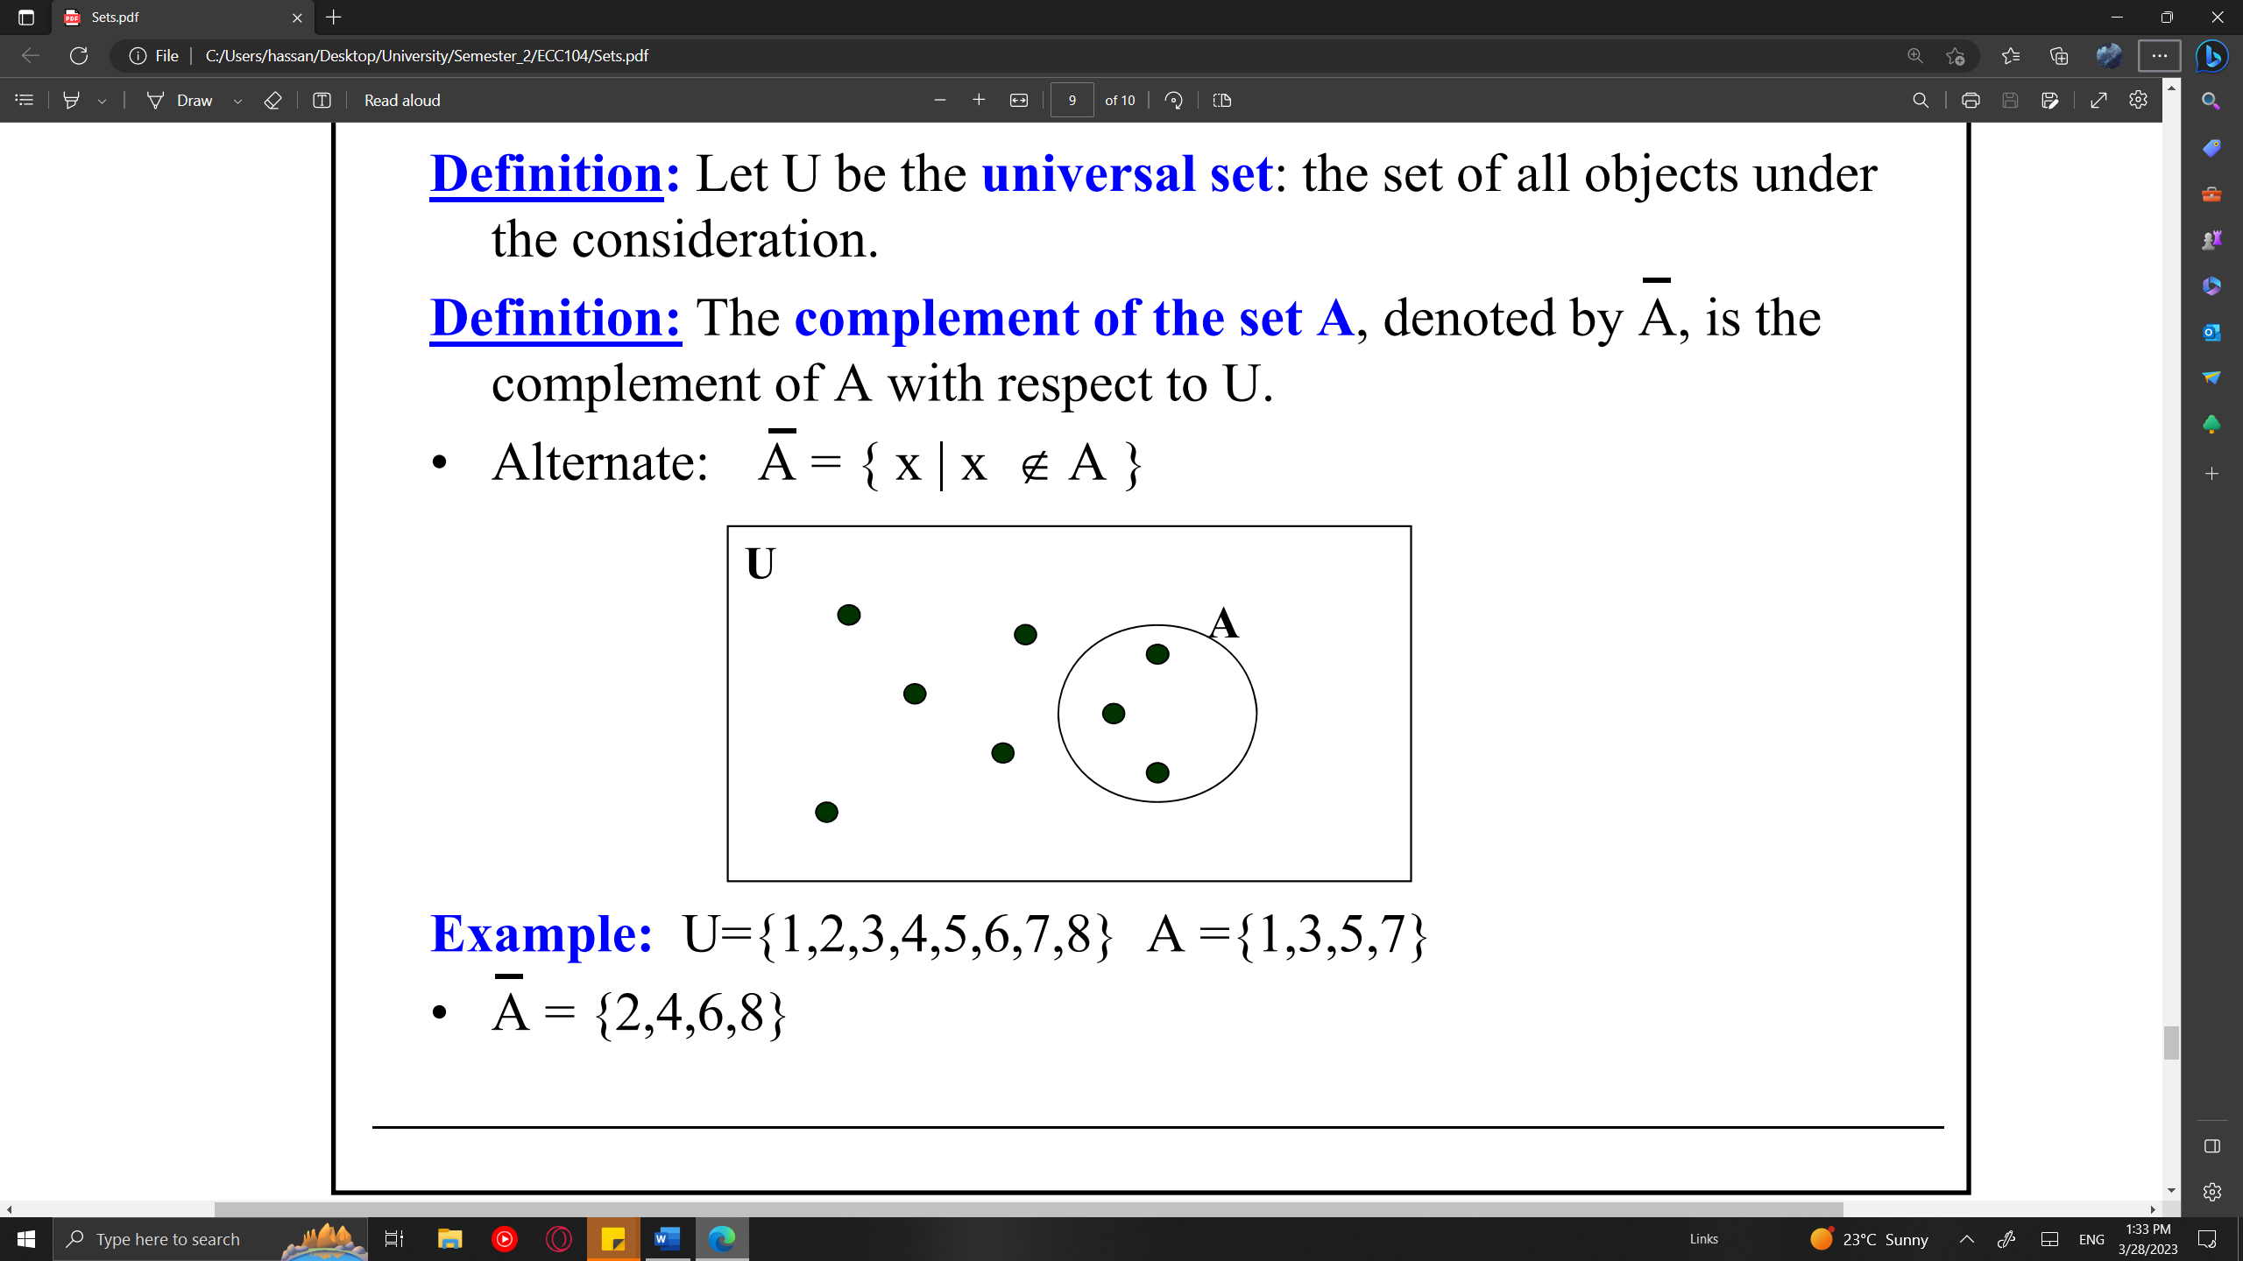

* Green
* Red
* Blue

Use the following Sets to answer Questions 18-20:

* U = {x | x ∈ Z ∧ -7 < x ≤ 5} ( reminder, U is the universal set, Z is the set of integers )
* A = {x | x ∈ U ∧ -1 ≤ x < 5}
* B = {x | x ∈ U ∧ x = 2x}

Question 18: B? ( Difficult )

* { -12, -10, -8, -6, -4, -2, 0, 2,4, 6, 8, 10 }
* { -6, -4, -2, 0, 2, 4 }
* { 0 }

Question 19: A ∩ B?: ( Easy )

* { -6, -4, -2, -1, 0, 1, 2, 3, 4 }
* { 0, 2, 4 }
* { -6, -4, -2 }

Question 20: B - A?: ( Easy )

* { -6, -4, -2, -1, 0, 1, 2, 3, 4 }
* { 0, 2, 4 }
* { -6, -4, -2 }

GG